Investment Proposal: Business Process Reengineering Project

Challenge: Inefficient Order Processing

The current order processing system is causing significant delays in fulfilling customer orders, leading to frustrated customers and lost business opportunities. The root cause of the problem lies in the manual, paper-based system that is prone to errors and lacks transparency. This results in incorrect or incomplete orders, multiple revisions, and extended wait times for customers.

Cost of Inefficiency: The cost of this inefficiency is significant and multifaceted. The company is losing customers due to long wait times and poor customer service. Additionally, the manual nature of the current system is leading to increased labor costs, as more employees are needed to manage the process.

Proposed Investment: $500,000

Diagramming Technique: Flowchart

The following flowchart illustrates the current order processing system and its inefficiencies:

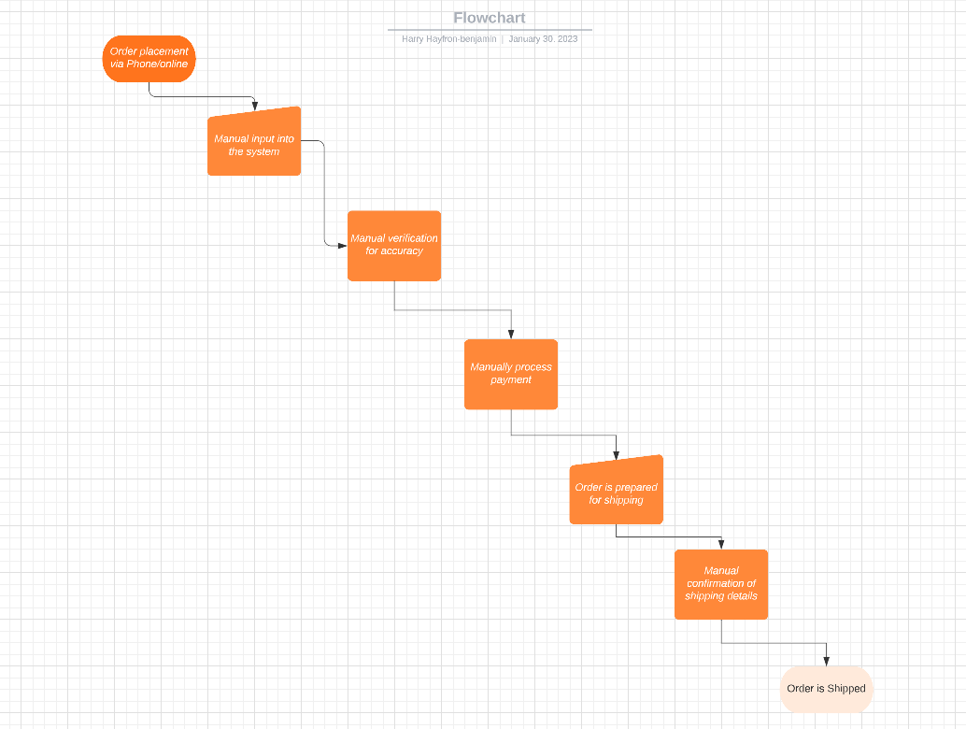

The flowchart highlights the manual steps involved in the current system, including data entry, manual order verification, and manual shipping confirmation. These steps create multiple opportunities for errors and delays, leading to increased wait times and decreased customer satisfaction.

In conclusion, the proposed investment in a business process reengineering project will address the inefficiencies in the current order processing system, resulting in significant cost savings and improved customer satisfaction.